**Ex 5 Dt.: 9/10/2013**

**Writing Device Drivers using FUSE**

**Objective:**

To write a simple user-space driver (application) using File system in User Space (FUSE) /perl in FUSE/ python in FUSE.

**Installation Procedure:**

1. Enter wget <TARBALL_URL> at the console to copy the tarball to system.  
   URL: http://sourceforge.net/projects/fuse/files/latest/download?source=files
2. Enter tar -xzf <TARBALL_FILENAME> to decompress and unpack the archive.
3. Navigate to the directory that contains the extracted FUSE files.
4. Enter ./configure to configure FUSE for compilation.
5. Enter make to compile FUSE
6. If the compilation completes successfully, enter make install to complete the installation of FUSE. In case of failure, read forth in http://fuse.sourceforge.net

Note: make sure you are not logged in root

**Aim**

To write an application to mount and unmount a folder as a file system in user space using File System in User Space (FUSE) in Ubuntu, that serves as an interface between file system and the kernel. This application sends a request to web and download the information searched by user. Then this information is displayed as a file in the virtual file system mounted using FUSE.

**Procedure:**

1. Install fuse-tutorial
   1. Download fuse-tutorial from http://www.cs.nmsu.edu/~pfeiffer/fuse-tutorial.tgz.
   2. Unzip it and change working directory to the unzipped directory, i.e., cd fuse-tutorial
   3. Enter cd src
   4. Type pkg-config fuse --cflags. And pkg-config fuse --libs.
2. Navigate to examples directory. You will find two directories rootdir and mountdir. We will download the file into rootdir and execute the mount routines to mount it to a virtual disk space mountdir.
3. Navigate to previous level using cd ..
4. Enter the command  
   sh downnmount.sh <URL> <FileName>
5. Now the file gets downloaded and the mounted filesystem shows up in the file browser.
6. Now enter the command  
   sh unmount.sh
7. Now the mounted file system gets unmounted.

**Program Code:**

**File:** downnmount.sh

#for downloading the file

wget $1 -O $2

#moving it to rootdir

mv $2 example/rootdir/$2

#now doing the mounting process

./src/bbfs example/rootdir/ example/mountdir/

**File:** unmount.sh

#unmounting the mounted drive

fusermount -u example/mountdir

**Output Screenshots:**

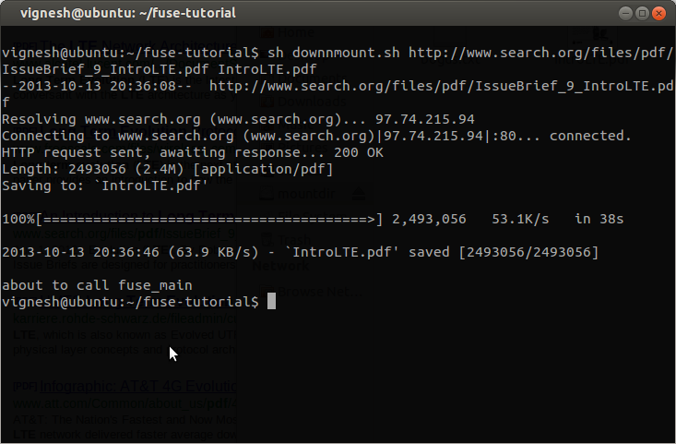

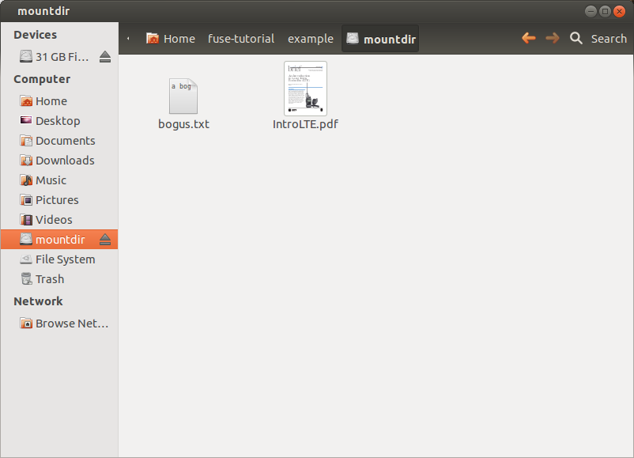

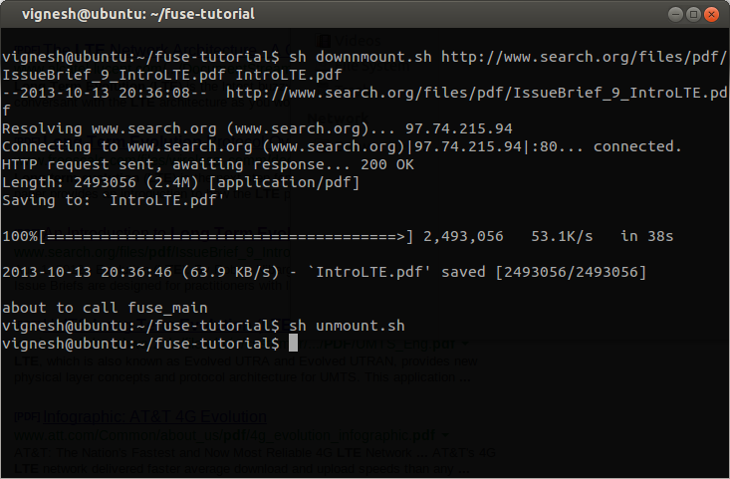

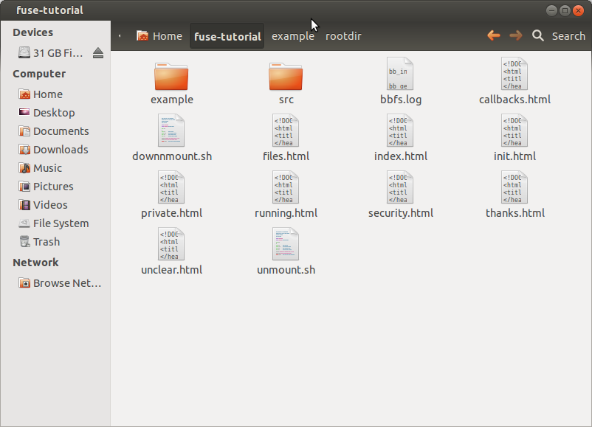

**Result:**

FUSE file system has been studied. A virtual drive has been creating by the mounting process. Additionally, a file has been downloaded from the Internet and its contents have been stored in the virtual drive.